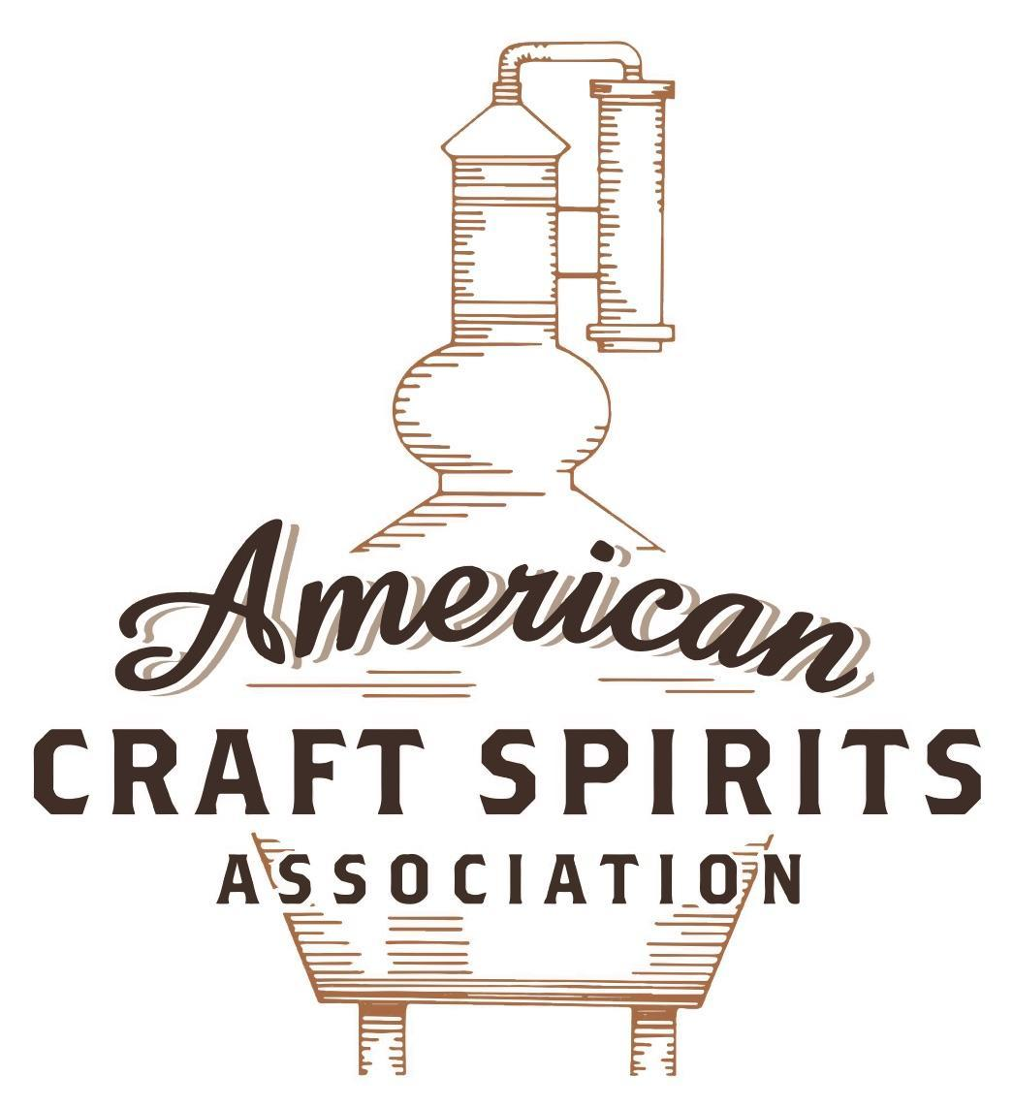
Spirits DtC Shipping Guide

This guide summarizes the direct-to-consumer shipping rules for distilleries in all 50 states and D.C. and also addresses the measures state governments have taken to ease delivery and shipping restrictions during the COVID-19 pandemic.

DtC Quick Guide Comparison

Out-of-State Distilleries  Can Ship Into State? |  |  |  | In-State Distilleries  Can Ship Within State?
State | Yes | No |  | State | Yes | No
AL |  | X |  | AL |  | X
AK | X |  |  | AK | X
AZ | X |  |  | AZ | X
AR |  | X |  | AR |  | X
CA |  | X* |  | CA |  | X*
CO |  | X |  | CO |  | X
CT |  | X* |  | CT |  | X
DE |  | X |  | DE |  | X
DC | X |  |  | DC | X
FL |  | X |  | FL |  | X
GA |  | X |  | GA |  | X
HI |  | X* |  | HI |  | ?*
ID |  | X |  | ID |  | X
IL |  | X* |  | IL |  | X*
IN |  | X |  | IN |  | X
IA |  | X* |  | IA |  | X*
KS |  | X |  | KS |  | X
KY | X |  |  | KY | X
LA |  | X |  | LA |  | X
ME |  | X* |  | ME |  | X*
MD |  | X |  | MD |  | X
MA |  | X |  | MA |  | X
MI |  | X |  | MI |  | X
MN |  | X |  | MN |  | X
MS |  | X |  | MS |  | X
MO |  | X |  | MO |  | X
MT |  | X |  | MT |  | X
NE | X |  |  | NE | X
NV |  | X* |  | NV |  | X
NH | X |  |  | NH |  | X*
NJ |  | X* |  | NJ |  | X*
NM |  | X |  | NM |  | X
NY |  | X* |  | NY |  | X*
NC |  | X |  | NC |  | X
ND | X |  |  | ND | X
OH |  | X |  | OH |  | X
OK |  | X |  | OK |  | X
OR |  | X |  | OR | X
PA |  | X* |  | PA |  | X
RI |  | X* |  | RI |  | X
SC |  | X |  | SC |  | X
SD |  | X |  | SD |  | X
TN |  | X |  | TN |  | X
TX |  | X |  | TX |  | X
UT |  | X |  | UT |  | X
VT |  | X |  | VT |  | X
VA |  | X |  | VA |  | X
WA |  | X* |  | WA | X
WV |  | X* |  | WV |  | X*

WI |  | X |  | WI |  | X
WY |  | X |  | WY |  | X

Notes:
*CA: If passed and signed into law, Senate Bill 620 would allow licensed distilled spirits producers in states other than California and licensed distilled spirits manufacturers or craft distillers in California who obtain distilled spirits direct shipper permits to ship directly to consumers in California
*CT: Consumers with appropriate permit may receive alcohol shipments
*HI: Consumers with appropriate permit may receive alcohol shipments; If passed and signed into law, Senate Bill 65 would allow licensed distilled spirits manufacturers in Hawaii and in states other than Hawaii who obtain direct shipper permits to ship directly to consumers in Hawaii
*IL: If passed and signed into law, Senate Bill 0532 would allow licensed distilled spirits producers in Illinois and in states other than Illinois who obtain distillery shippers’ licenses to ship directly to consumers in Illinois
*IA: If passed and signed into law, House File 639 would allow native distilled spirits manufacturers in Iowa and in states other than Iowa who obtain direct shipper permits to ship directly to consumers in Iowa and to consumers in states other than Iowa
*ME: If passed and signed into law, Legislative Document 1358 would allow distilleries outside of Maine with current manufacturer licenses and distilleries licensed in Maine who obtain spirits direct shipper licenses to ship directly to consumers in Maine
*NJ: (1) If passed and signed into law, Assembly Bill 3167 would allow a craft distillery licensees to ship no more than 9 liters of distilled spirits to a consumer in New Jersey; (2) If passed and signed into law, Senate Bill 3020 would allow craft distillery licensees in New Jersey or in states other than New Jersey to ship no more than 20 liters of distilled spirits to a consumer in New Jersey via common carrier
*NV: Licensed individuals can import one gallon per month of spirits for personal use and the out-of-state supplier must pay excise tax
*NH: If passed and signed into law, Senate Bill 125 would allow licensed liquor manufacturers who obtain direct to consumer shipping permits from the commission to ship directly to consumers in New Hampshire
*NY: Consumer may import up to 90L of liquor per year for personal use without a license; If passed and signed into law, Assembly Bill 3275 would allow licensed liquor manufacturers in states other than New York and licensed distillers and farm distillers in New York to ship no more than thirty-six cases (no more than nine liters per case) of liquor to consumers in New York
*PA: Consumer may place a special liquor order and distiller must ship to a PLCB-operated store
*RI: Distiller can only ship to customer if order was personally placed by customer at distiller's premises
*WA: If passed and signed into law, House Bill 1432 would allow licensed spirits manufacturers in states other than Washington to ship spirits to consumers in Washington
*WV: Distilleries, mini-distilleries, or micro-distilleries licensed in West Virginia or a state other than West Virginia who obtain private direct shipper licenses to ship to a consumer in West Virginia, however the shipments must be made to a retail liquor outlet

SOUTH CAROLINA
Shipment Outbound – Yes, if permitted by the customer’s applicable laws (S.C. Code Ann. § 61-6-100(1); 1150(2)).
Shipment Inbound – No, out-of-state registered producers must ship alcoholic liquors into licensed warehouses (S.C. Code Ann. § 61-6-2820; § 61-6-2900).
Shipment Intra-state – No, manufacturers must sell and deliver to wholesalers or sell to consumers at their licensed premises (S.C. Code Ann. § 61-6-100; § 61-6-1150).
COVID-19 Measures – Relief measures did not include distilleries. Curbside delivery and pickup of alcoholic liquors remain prohibited.
Link: https://dor.sc.gov/tax/abl
Citation (shipment)
South Carolina Code Annotated
SECTION 61-6-100. Authority to issue, suspend, and revoke licenses.
(1) manufacturers' licenses which authorize the licensees to manufacture alcoholic liquors and to sell and deliver or ship them, in accordance with regulations, in bottles or in similar closed containers to a person in this State who has a wholesaler's license issued under this article, and in barrels, bottles, or other closed containers to persons outside this State. However, no deliveries or shipments may be made into another state whose laws prohibit the consignee from receiving or selling alcoholic liquors.
SECTION 61-6-1150. Tastings and retail sales; additional limitations and requirements.
Authorization by this section of sales and tastings at licensed premises of a micro-distillery or manufacturer is expressly intended for the promotion of education regarding production of alcoholic liquors in the State and not to create competition between producers and retailers. A holder of a valid micro-distillery or manufacturer license issued by the State may:
(1) sell in any quantities the alcoholic liquors produced at the licensed premises to a wholesaler licensed by the State;
(2) transport in any quantities the alcoholic liquors produced at the licensed premises out of state for sale outside of the State;
(3) sell at retail at the licensed premises the alcoholic liquors produced at the licensed premises, but only if the labels for the bottles are marked "not for resale";
(4) sell at retail no more than the equivalent of three 750-milliliter bottles of alcoholic liquors to a consumer in one business day;
(5) not allow consumption on the licensed premises of alcoholic liquors sold by the bottle at the licensed premises;
(6) maintain pricing of the alcoholic liquors sold at the licensed premises at a price approximating retail prices generally charged for identical alcoholic liquors in the county where the on-site premises is located;
(7) in addition to the sale of alcoholic liquors as authorized by this section, sell items promoting the brand or brands of alcoholic liquors produced at that location in a room on the licensed premises separate from the locations of the tastings;
(8) not sell or store goods, wares, or merchandise in or from the room in which alcoholic liquors are sold or tasted;
(9) store mixers used, but not sold, in conjunction with tastings; and
(10) not allow minors into the portion of the facility where tastings are occurring.
SECTION 61-6-2820. Importation by registered producers.
No person other than a registered producer may ship, move, or cause to be shipped or moved alcoholic liquors from a point outside the State to a point inside the State, and then only in accordance with the provisions of this article.
SECTION 61-6-2900. Shipment or transfer of imported liquors.
Alcoholic liquors must be shipped or moved from a point outside this State to a point inside the State only by railroad companies, steamship companies, express companies, or truck companies authorized to do business in the State as common carriers by the Department of Public Safety, by wholesalers licensed by the department, or by registered producers in their own trucks. Alcoholic liquors must be shipped or moved only to the warehouse of the food manufacturer licensed pursuant to Section 61-6-710, or the registered producer in care of the producer representative who is registered to handle the property of the registered producer originating the shipment. The shipment of alcoholic liquors must be either stored in the warehouse of the food manufacturer licensed pursuant to Section 61-1-710 or in a licensed warehouse of the registered producer or, after delivery to the producer representative is complete, may then be shipped to a licensed wholesaler by common carriers described in this section, by wholesalers licensed by the department or by registered producers in their own trucks.

Link to statutes: https://www.scstatehouse.gov/code/t61c006.php

The American Craft Spirits Association (ACSA) is working diligently to give our members and industry partners relevant, current updates on statutes and regulations impacting production, sale and distribution of spirits. With the declaration of the novel coronavirus (COVID-19) in early 2020, many states have issued temporary policy changes or longer-term modernization of alcohol beverage laws. State statutes, regulations created by the state alcohol regulatory authority, as well as any other relevant guidance provided by such authorities (such as advisories, opinions, bulletins, etc.) were reviewed in creation of this document. No city or county ordinances were reviewed. Distillers should be aware that even in states where direct shipping is permissible, always remember to avoid shipping to dry counties. Please consult with your state guild or alcohol beverage authority for the most up-to-date information. This content is intended for educational and informational purposes only. ACSA's pro bono law firm of Malkin Law P.A. provided the core content found in this comprehensive overview of the spirits distribution after COVID-19. It was completed in August 2021 and will be updated regularly. If you have updates you would like to provide, please send to legislation@americancraftspirits.org or directly to the law firm at: ryan@malkin.law / malkin.law. Thank you.

